So, where does my story start?

Back in May 2017, I struggled with major depression and anxiety and didn’t want to be here, however, I’ve been up and down and kept myself floating above water via exercise for some time and I’ve always talked about introducing proper nutrition in to my daily life, but never pursued the talk with actions, however, at the beginning of UK lockdown I stopped talking and starting actioning, and the rest, well that is history.

It was the 15th March 2020, and I was sat on a train after a heavy weekend at a gig with my friends, coming back to Hull from London, I felt like on that train journey I slumped to my lowest point from May 2017 and I never wanted to feel like that and think like I did in 2017 and I genuinely believed I was going back to 2017 on the train journey.

On the 16th of May, I was feeling so low, I wrote down all the ‘things’ in my life which made me miserable and I could control, and then I went on a journey to eliminate them one by one (drink and unhealthy takeaways) while keeping the things I did enjoy in my life which was exercise and music, I always knew exercise aided the release of stress of general life, stress of work, excessive partying on a weekend which caused me so much pain the in the past.

So, the official UK lockdown was implemented on 23rd March 2020, and I decided to take up running to aid the release of feelings of anxiety, depression and sadness which built up over years and years of family issues.

Running was going really well until about 2 weeks in to running and I damaged my knee and I had to stop running which could’ve really set my back however, it didn’t, I carried on, instead of running, I started long distance walking and while walking I decided I wanted to take myself on journey of getting myself fit and healthy Incase I was one of the unfortunate people who caught COVID, because at this time I wasn’t healthy, I weighed in at 14st 13ibs and couldn’t breathe properly at the time and that really scared me after hearing what I heard on the news about COVID.

So, I started to read around topics on nutrition and dieting, and wanted to lose some weight and that’s when I started to embark on an epic lockdown journey and that’s where’s my Instagram name came from ‘lockdownholborn’ and in UK lockdown I’ve learnt so much about exercise and nutrition and it’s helped me grow so much as an individual from both a personal and work prospective, I exercised 3 times a week and walked 5 times a week every week since the begging of lockdown, and from there, below is the journey you will see, I never gave in and as time went out I looked better, felt better, thought better and started to believe in everything I said, actioned or looked at:

From the 23rd March 2020 to the time I wrote this blog I’ve lost a total of 2st 9ibs and I’ve been sertraline (antidepressant) free 5 weeks as of the 13th July 2020.

**This is me on my first office UK lockdown run (25th March 2020):**

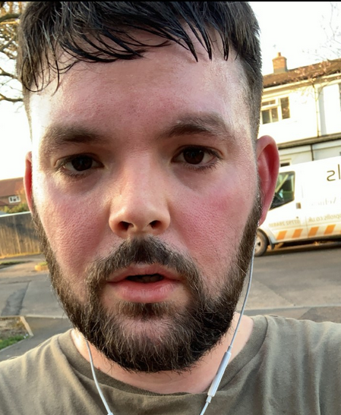

**Here is me 25th May:**

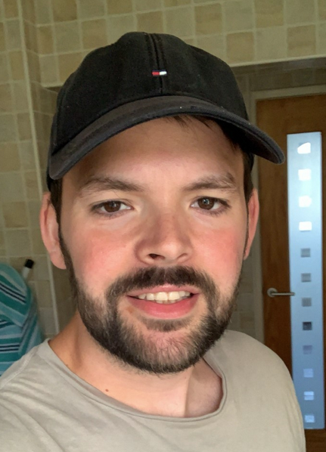

**Here is me 9th July:**

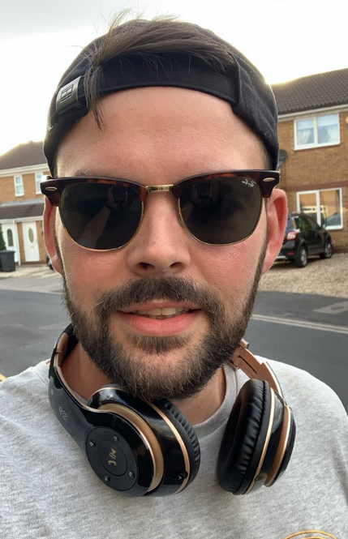

I’ve been through so much in my life, uncontrollable and controllable variables, I’ve been broken, plugged away, make rash decisions, dived head first at things which I shouldn't have, at time’s I’ve bitten off more than I chew at times and I’ve been a part and made some absolutely epic memories along the way in 29 years with family, friends and work colleagues.

But one thing for sure is, I’ve finally shut that chapter down in my life and I’ve opened up about my struggles and people keep asking me why I started this journey and why I’m doing this, people say I’m doing it for ‘likes’ or for ‘followers’ and one thing for sure is I don’t do it for none them, I do it for people who want to make change mentally or physically because I’ve been to the darkest place my mind could possibly take it and at that point I didn’t want to be here.

Currently this is the happiest mentally I’ve ever been, it’s the healthiest I’ve looked in my face, within and outside mentally and physically, and job satisfied I’ve ever been. Now I’m ready to propel and finally realise that inner self and people have been saying ‘you’re scaring me, I’ve never heard you speak so positive and sound so motivated in life’ to get what you want.

ALL I CAN SAY IS MENTAL HEALTH MATTERS. And don’t hesitate to reach out to me because I’ll always try and make time for anyone irrespective of race, culture, mental state, political stance because I know what it feels like to be in the darkest place and if I can help people out of their unhappiness then my life would be complete ❤️

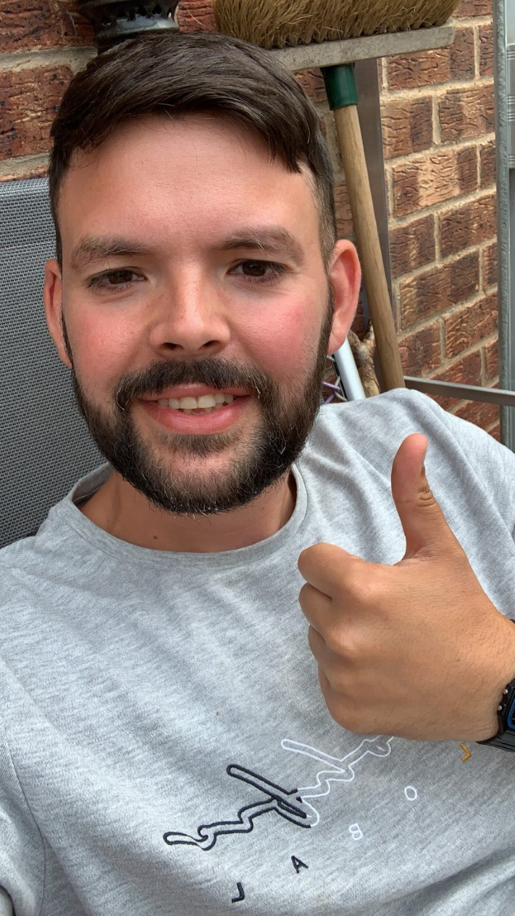

Yours sincerely

Lockdown Holborn