OCD and Coronavirus Survival Tips
Because of the increased media coverage, much of which is unhelpful, we wanted to share some practical suggestions to help you cope and survive the ongoing situation. Our survival tips are to help you differentiate between the recommended public health advice for this virus and OCD induced behaviours, but also to help you combine therapeutic steps whilst engaging in these recommended behaviours.
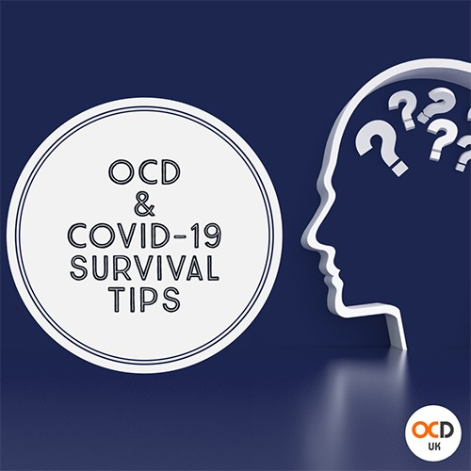
- 20 seconds, and not a second longer!
The advice from health professionals is to be careful not to touch our face and regularly wash our hands for 20 seconds. We know that this gives the OCD monster the perfect motive to come crashing in and try to disrupt all the hard work you have put in during recovery. So here’s where you can still stay in control of the bully. You must ONLY wash your hands as frequently as the health professionals tell you to, and only for 20 seconds. We know all too well how it feels to hear that bully voice in your brain saying, ‘just one more time’ or ‘just a few seconds longer’. Before we know it, its escalated to five times, 5 minutes per time. Remember the limits and stick to them… you CAN do this.

- Be kind to yourself
Despite our suggestion above, there will be times when OCD gets the better of us. So if 20 seconds does become 30 or even 60 seconds occasionally, or if you do send a text to a loved one for reassurance, its ok, don't beat yourself up. It's vitally important that we remember to be kind to ourselves by showing ourselves the same compassion we show to others. Be honest with yourself (about the OCD work needed), but be compassionate. Have your targets (i.e. 20 seconds), aim for them, but don't beat yourself up for the occasional miss.
- Challenge your OCD in other ways
For some people behavioural exercises have taken a diversion, so it's important to be mindful of other ways we can keep on top of things. If there are other behavioural exercises you can be working on, which stay in line with health advice on COVID-19, do them.
- Don’t allow OCD to dictate self-isolation
Whilst respecting the recommended social distancing, it's important we only actually isolate if we have genuine symptoms of COVID-19 or have been officially recommended to. This is where it gets tricky for OCD sufferers, because as we know all too well OCD likes to play tricks on us. It is no secret that when someone with OCD is fixating on an obsession, it can cause physical sensations in the body. You might notice harmless physical sensations, worry what they are and before we know it, we are panicked. That inevitably causes shortness of breath which convinces us we have coronavirus. Remember your therapy techniques!
- Limit yourself to time spent on social media
We are all guilty of it. Whenever you get a spare second you flick through Facebook, Twitter and Instagram. However, at the moment there’s more scaremongering than ever. The general media are also not helping, they are desperately relying on clickbait to sell headlines and it's working. Limit yourself on how long you spend on social media, delete notifications if you need to and focus on the real facts.
Information can be (non-OCD) reassuring provided it's rooted in facts. Educate yourselves with real factual evidence and ignore articles with fake news. Good examples for factual information are gov.uk, NHS111 and the BBC News.
- Protect mental well-being - Don't be afraid to mute / unfollow / block / unfriend
Even during normal times it's important when challenging OCD that we surround ourselves with positivity and limit the amount of negative influences in our lives. This is so important now more than ever! Don't be afraid to mute or unfollow news outlets or people that push more negativity than positivity into your timeline. Unfollowing someone is not always easy to do, but do what is right for your mental well-being.

- You can still do therapy
I have coronavirus, I have coronavirus, I have coronavirus, I have coronavirus. Be your own therapist, think about exercises that you can do, like getting used to the thought. Put a sign on your door; ‘I have coronavirus’ and help your OCD get used to the thought… we don’t have to like the thought, we don’t want the thought to become a reality, we just have to accept the thought without reaching for the soap.
- You can still....
Social media and the newspapers are full of what you can't do, so it may be helpful to remember what is still possible, even if you have to self-isolate.

You can still: Listen to your favourite music
You can still: Talk and Skype family and friends
You can still: Read your favourite book/s
You can still: Enjoy the outdoors, even if it's your own garden in the short term
You can still: Sing or dance at home (even if both are best behind closed doors!)
You can still: Smile and laugh (don't let OCD stop either, it will try, we don't have to let it stop us smiling or laughing)
You can still: Watch your favourite TV or films (we recommend the fun, laugh out loud variety!)
You can still: Have HOPE for a life without OCD (even if that comes after this public health crisis)

